**Brief Profile of Dr S Mohan Kumar** 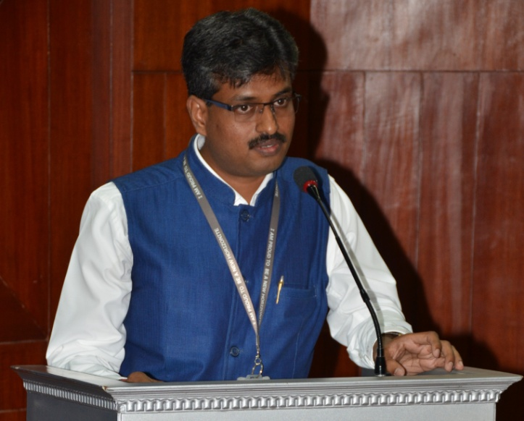

Dr. S. Mohan Kumar M.E[CSE]., M.Tech[Software Engineering].,PhD[CSE] has two decades of experience in the fields of academic administration, research, Quality Assurance and also in educational consultancy. He has six years of experience as Head of the department IT/CSE. He is Editor-in-Chief of International Scientific Journal of Contemporary Research in Engineering, Science and Management. He is Microsoft Certified Professional in SQL Server. He is author of over 70+ scholarly research/ review papers, including 40+ reputed and peer reviewed international journal(Scopus/SCI/UGC) papers with 40+ Citation index and 10+ h-index. He has won several research paper awards in different National and International conferences and symposiums. He field around 8 patents. He is Member in 20+ leading professional Societies and Forums. He is reviewer and editorial board member/ Advisory board for 24 reputed/ UGC approved International/ National Journals and has published 5 Technical books in the field of Computer Science. He received IEAE Young Achiever Award in the year 2016. He received **Integrated Intelligent Research** Society, India -Republic Day Achievers Award – Best Faculty Award in the year 2017. He received IEAE, India - Best Faculty Award in the year 2018 & Research Excellence Award 2018. He has won prizes and medals for his research contributions in National and International Research competitions. His current research interests include High Performance Computing, Image Processing, Machine Learning, Data Science and Analytics, Learning Systems, Algorithm Design for emerging Medical Image and Video data analysis and Advanced Network and Cyber Security. Presently he is guiding PG & PhD Scholars in the fields of Medical Image Processing, Edge Computing, Data Science and Internet of Things. He is an ISO 9001-2015-Quality Management System and 14001-2015 Environmental Management System – Certified -Lead -Auditor. Presently he is Associate Professor & R&D and Quality Assurance Co-ordinator of the Department of Information Science and Engineering, New Horizon College of Engineering, (Autonomous Institution, NAAC A grade, NBA- Accredited Institution, ISO Certified), Bangalore. His professional visit to many countries including Spain, Portugal, Russia, Germany, Thailand and Israel resulted in better collaborations.